Sprint 1, D0018E Group 34

# User Roles:

* Employee (with a column for special sub roles like Manager/Administrator that would unlock more permissions)
* Customer

# Scenarios:

* Employee adds a new product
* Employee edits/deletes a product
* Customer logs in on site and buys a product
* Customer submits a contact form

# Architecture:

Bootstrap for HTML, PHP/Python for Server and MySQL for DB

GitHub link to code repository: <https://github.com/Mawn/D0018E-Databaser>

# E-R Diagram:

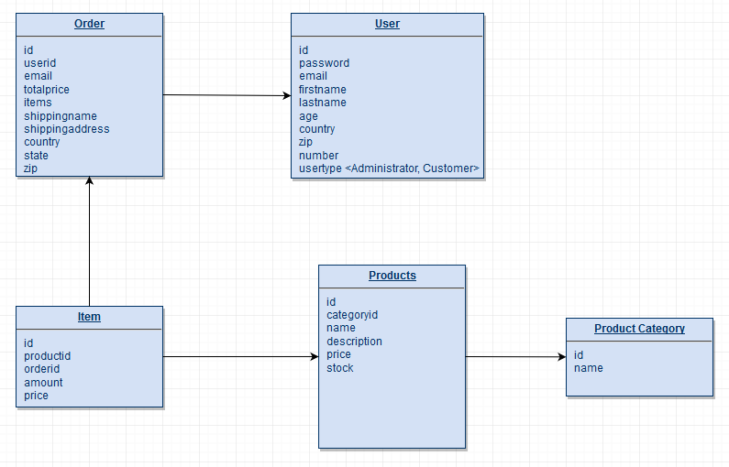

# Backlog:

